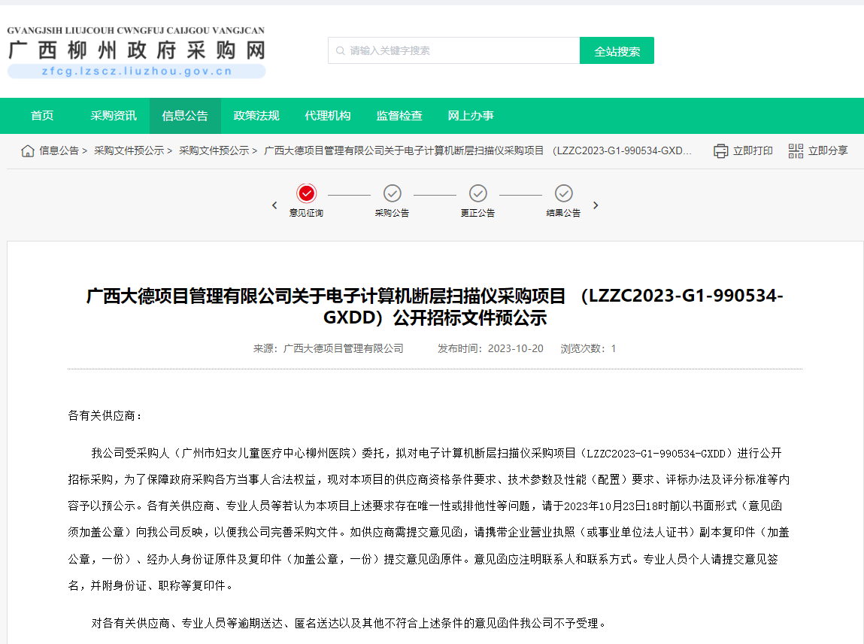
http://zfcg.lzscz.liuzhou.gov.cn/site/detail?parentId=138102&articleId=3W12u14TkemYNW2bpOSR1A==&utm=site.site-PC-42049.1069-pc-wsg-ArticlePurchaseNoticeList-front.2.f1e74ea06f3211eea1b163fd83c159c8

