**关于消化道动力检测系统采购（LZZC2023-G1-990496-GXDD）公开招标文件预公示**

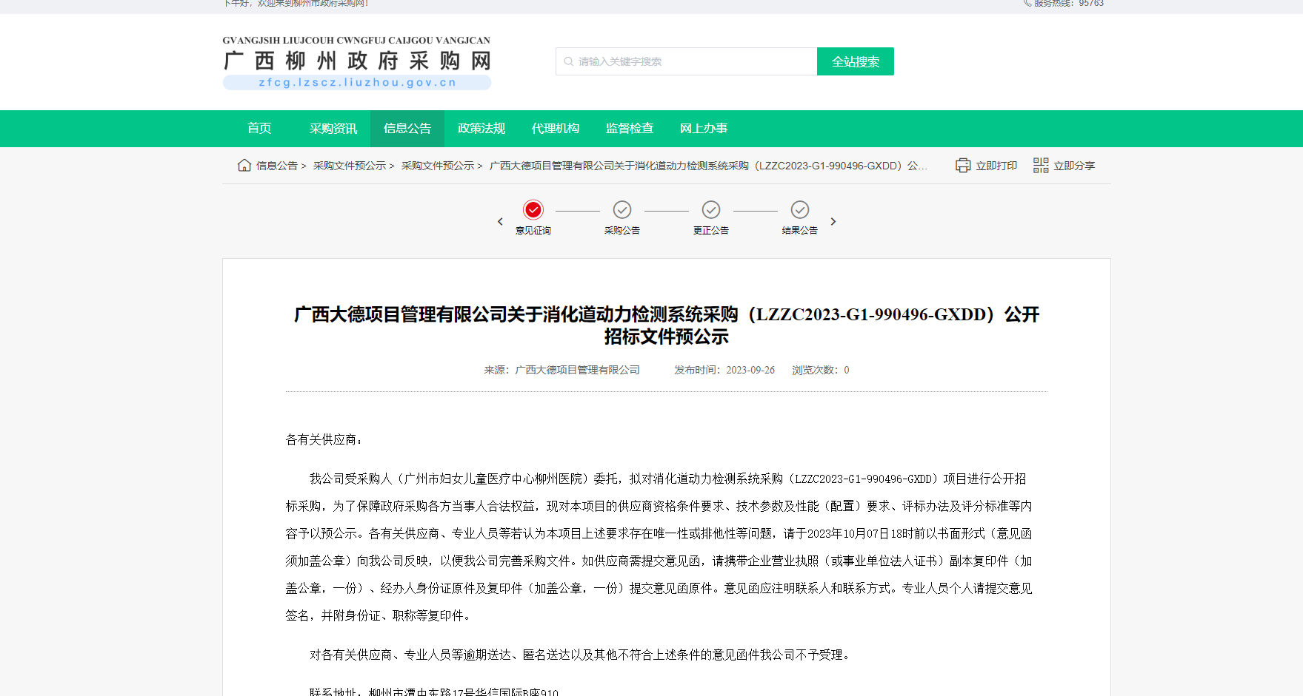http://zfcg.lzscz.liuzhou.gov.cn/site/detail?parentId=138102&articleId=XZN9uFh33vlpdRXHo51yjg==&utm=site.site-PC-42049.1069-pc-wsg-ArticlePurchaseNoticeList-front.2.a54b5fb05c3011eeb33f4f3d7ac6f347