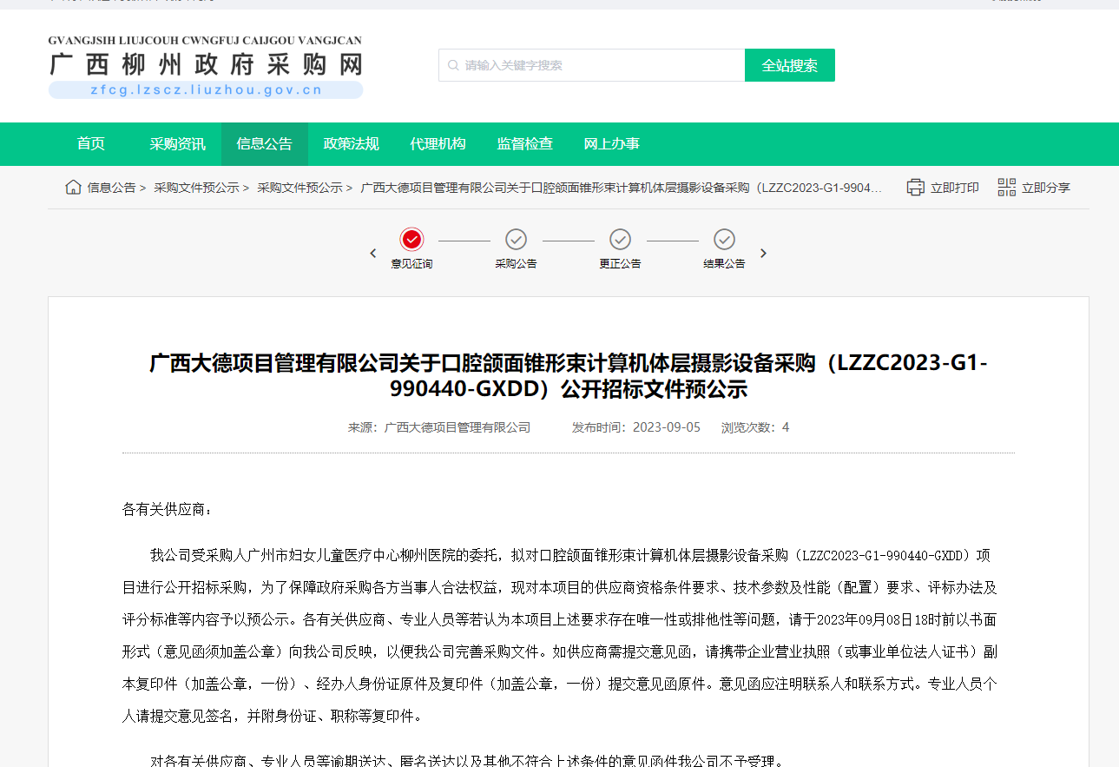

网址：

http://zfcg.lzscz.liuzhou.gov.cn/site/detail?parentId=138102&articleId=9+iko8tC2Lo8oKlqDq/gXw==&utm=site.site-PC-42049.1069-pc-wsg-ArticlePurchaseNoticeList-front.2.41eec9104ba111ee87e4b9bad35cca2d